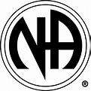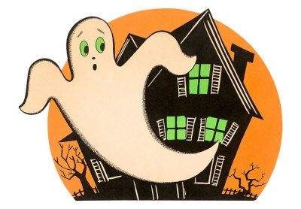

**Emerald Coast NA Annual Halloween Party**

***Saturday, October 27, 2018***

***6 pm to 11 pm***

***Where: City of Parker Recreational Center (***not affiliated with Narcotics Anonymous)

1001 West Park Street, Parker, FL. 32404

***Schedule of Events: 6 PM to 7 PM - Speaker Meeting (Mark V. to be guest speaker)***

***7 PM to 11 PM – Dancing and Socializing***

***8 PM – Kids Costume Contest***

***9 PM – Adult Costume Contest***

***10 PM – Silent Auction***

**FOOD, BEVERAGES, PRIZES AND FUN**

**$5.00 suggested donation**

**BRING A NEWCOMER AND LET’S SHOW THEM HOW WE HAVE FUN IN**

**RECOVERY!**

Any questions contact: 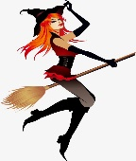 Melissa D. @ (850) 899-7584

**OR**

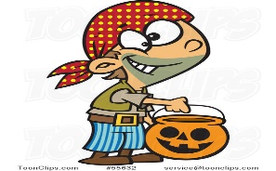Charlie H. @ (858) 243-3353